IELTS Academic Writing Task 1 Activity – Student’s Worksheet

Exercise 1

Understanding the task and data

- What four pieces of information do you learn from the four sentences above the chart?
- Should candidates just copy the information on the question paper for their introductory statement?
- Is the information about High School students?
- Is the information about one period of time only?
- Does the data in the darker colour refer to full-time students?
- Do the first three pairs of bars and figures refer to men only?
- According to the table, were 200 males in full-time education in Britain between 1990 and 1991?

Exercise 2

Analysing a sample answer

- In this answer, does the candidate talk about males or females or both?
- Does it focus on one specific year in each separate sentence?
- Is the answer written in bullet points or note form?
- Is there a separate introduction or conclusion?
- How is the answer organised?
- Is there a range of structures, vocabulary and grammar?
- Do you think spelling and grammar have been checked and self-corrections made?

IELTS Academic Writing Task 1 Activity – Sample Task

Academic Writing Sample Task 1A
You should spend about 20 minutes on this task.

The chart below shows the number of men and women in further education in Britain in three periods and whether they were studying full-time or part-time.

Summarise the information by selecting and reporting the main features, and make comparisons where relevant.

Write at least 150 words.

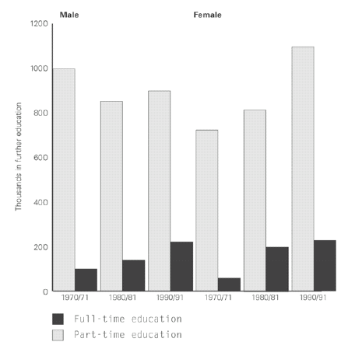

IELTS Academic Writing Task 1 Activity – Sample Answer

The bar chart illustrates how many males and females have studied in full-time and part-time education in the following years: 1970 to 1971, 1980 to 1981 and 1990 to 1991.

It is clear that in all three time periods more people of both sexes were involved in part-time education than full-time. Overall the number of men in full-time education rose from approximatly 100 thousand to 200 thousand, whereas the number of men in part-time education was lower in the early nineties than twenty years earlier.

As far as women are concerned, the numbers increased in both sectors of education. The number of part- time female students increased dramatically from 700 thousand to 1.2 million in the twenty year period. The amount of women in full-time education went up more gradually from 100 thousand in 1971 to just over 200 thousand in 1991. This was similar the increase for full-time male students.

To sum up, the number of women in both sectors increased significantly while it seems that the rate of men entering part-time education decreased a little and was fluctuating.

